**Solving Equations (Single variable)**

Linear equations state the equality of two expressions involving a variable. The solution to an equation is the value of the variable that satisfies the given condition. We solve equations by isolating the variable (unknown) on one side of the equation to find its value.

$2x-4+8=4\left(2+4\right)$

At the heart of linear equations lies the idea of balance. The equal signs represent that $2x - 4+8$ is equal to $4\left(2+4\right)$. Our task is to isolate the variable x while ensuring both sides remain equal.

Think of the linear equation as a balanced seesaw. If we add or remove weight from one side, the seesaw would lose its balance and one side would go up. However, if we add or remove weights on both sides, it remains balanced. We can use this same principle to solve linear equations. Whatever operation we perform on one side, we must perform on the other to maintain balance.

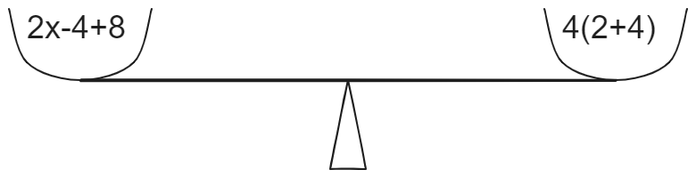

Let’s solve this linear equation step by step.

**Simplify Both Sides**

We can start by simplifying both sides of the equation. Combine like terms and perform any necessary operations to make the equation as straightforward as possible. Notice that we aren’t removing or adding anything extra to either side. We are just simplifying the expressions on both sides. Therefore, the equation will remain balanced during this step.

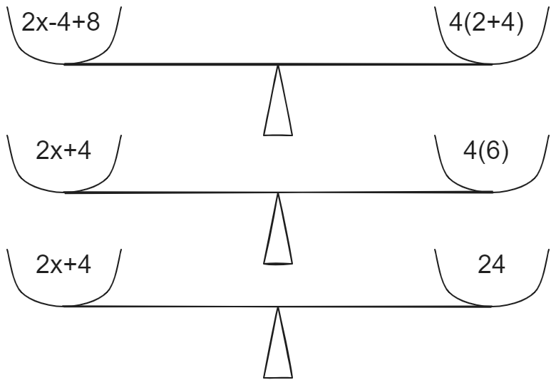

**Isolate the Variable**

Now, we need to isolate the variable (x) on one side of the equation. To achieve this, we must perform the inverse of each operation involving the variable on both sides of the equation.

In our example equation, $2x+4 = 24$ we can get rid of +4 by subtracting 4 from that side of the equation.

$=2x+4-4=2x$

If we do that the left side of the equation would be 4 less than the right side and the equation would lose the balance.

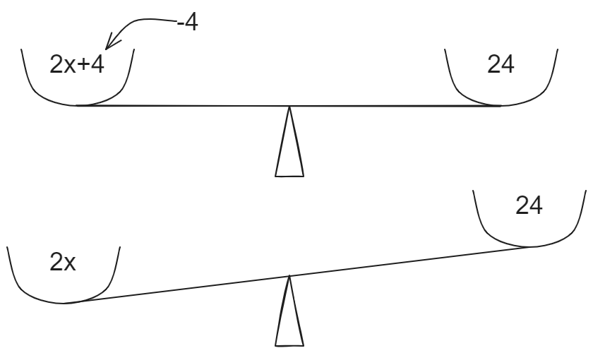

We can subtract 4 from the right side to preserve the balance (equality) of the equation.

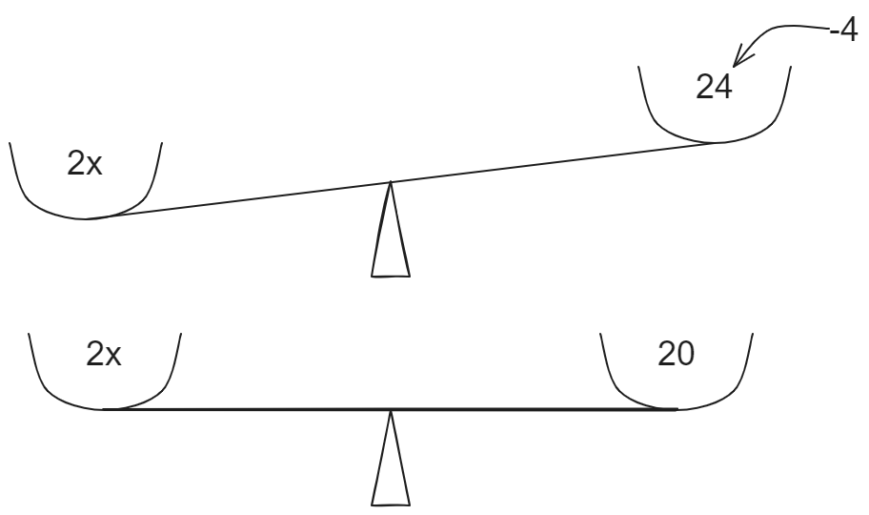

We have to follow the same process for all the other operations associated with the variable.

* If something is added to the variable, we subtract it from both sides.
* If the variable is multiplied by a number, we divide both sides by that number.
* If it’s divided by a number, we multiply both sides by that number.

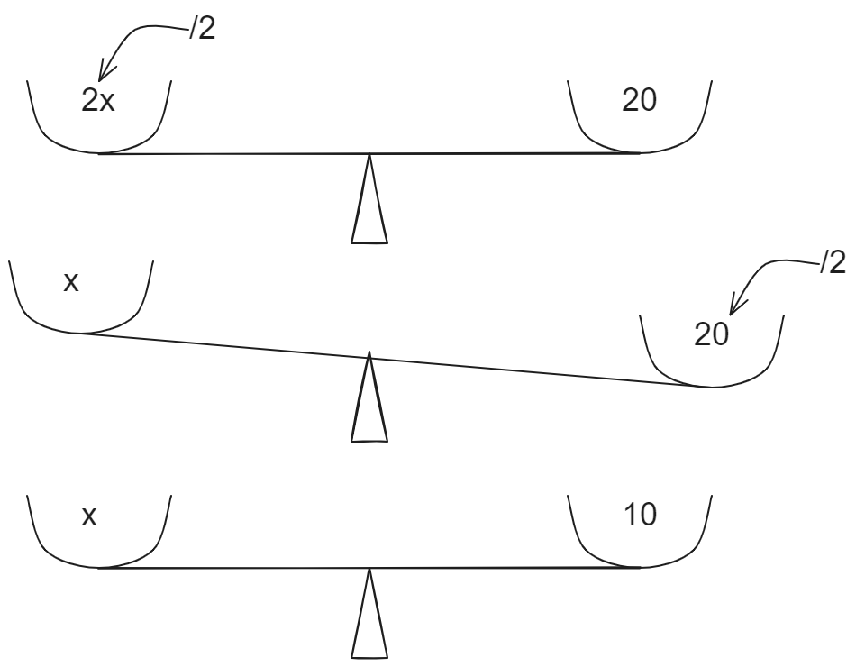

**Check Your Solution**

We found the value of x to be 10. It is a good practice to check your answer by substituting the answer for x in the original equation. If everything simplifies to a **true statement**, you’ve solved the equation correctly!

$2x-4+8=4\left(2+4\right)$

$2\left(10\right)-4+8=4\left(6\right)$

$20+4=24$

$24=24$ ✅

**Let's Practice with Examples**

**Example #1**

$4(x-5)=12$

1. Step one - Simplify both sides.
$4x-20=12$

2. Step two - Isolate the variable

$4x-20+20 =12+20$

$4x = 32$

$\frac{4x}{4}=\frac{32}{4}$

$x = 8$

**Example #2**

$3x-4=2x+6$

1. Step one - Simplify both sides.

* In this example, both sides are already simplified.

1. Step two - Isolate the variable

* Subtract 2x from both sides to move the variable terms to one side

$3x-2x-4=2x-2x+6$

$x-4=6$

Add 4 to both sides to isolate the variable x

$x-4+4=6+4$

$x=10$

1. Step three - Check the solution

+ 6

$26=26$ ✅